A PYTHON PROGRAM TO IMPLEMENT KNN MODEL AND K-MEANS MODEL
Name: Sugitha N
Rollno.: 241801279
EXP: 9
Code:
import numpy as np
import matplotlib.pyplot as plt
import pandas as pd
from sklearn.cluster import KMeans

dataset = pd.read_csv('../input/mall-customers/Mall_Customers.csv')
X = dataset.iloc[:, [3, 4]].values
print(dataset)

wcss = []
for i in range(1, 11):
kmeans = KMeans(n_clusters=i, init='k-means++', max_iter=300, n_init=10, random_state=0)
kmeans.fit(X)
wcss.append(kmeans.inertia_)

plt.plot(range(1, 11), wcss)
plt.title('The Elbow Method')
plt.xlabel('Number of clusters')
plt.ylabel('WCSS')
plt.show()

kmeans = KMeans(n_clusters=5, init='k-means++', max_iter=300, n_init=10, random_state=0)
y_kmeans = kmeans.fit_predict(X)
print(type(y_kmeans))
print(y_kmeans)

plt.scatter(X[y_kmeans == 0, 0], X[y_kmeans == 0, 1], s=100, c='red', label='Cluster 1')
plt.scatter(X[y_kmeans == 1, 0], X[y_kmeans == 1, 1], s=100, c='blue', label='Cluster 2')
plt.scatter(X[y_kmeans == 2, 0], X[y_kmeans == 2, 1], s=100, c='green', label='Cluster 3')
plt.scatter(X[y_kmeans == 3, 0], X[y_kmeans == 3, 1], s=100, c='cyan', label='Cluster 4')
plt.scatter(X[y_kmeans == 4, 0], X[y_kmeans == 4, 1], s=100, c='magenta', label='Cluster 5')
plt.scatter(kmeans.cluster_centers_[:, 0], kmeans.cluster_centers_[:, 1], s=300, c='yellow', label='Centroids')
plt.title('Clusters of customers')
plt.xlabel('Annual Income (k$)')
plt.ylabel('Spending Score (1-100)')
plt.legend()
plt.show()
output:
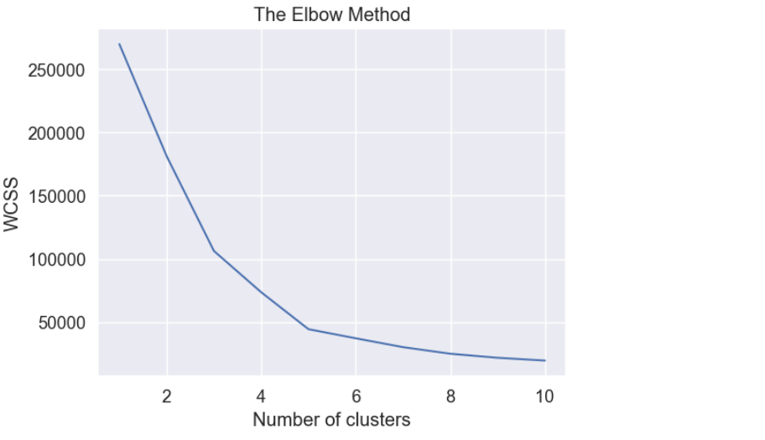
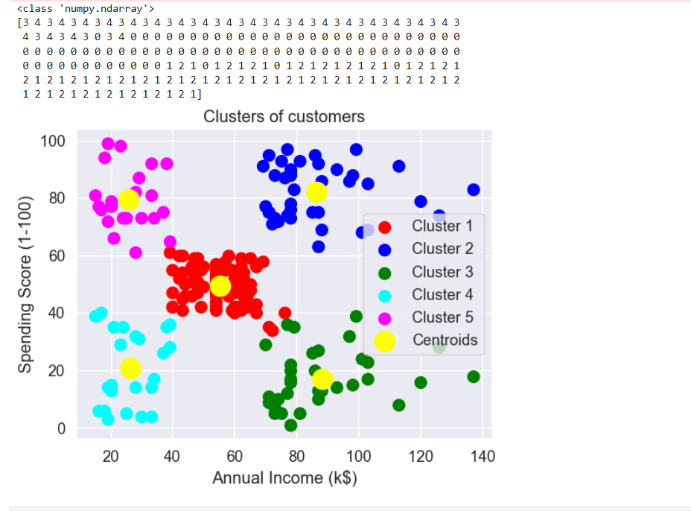
A PYTHON PROGRAM TO IMPLEMENT K-MEANS MODEL
Code:
import pandas as pd
import numpy as np
from math import sqrt

data = pd.read_csv('../input/k-means-clustering/KNN (3).csv')
req_data = data.iloc[:, 1:]

shuffle_index = np.random.permutation(req_data.shape[0])
req_data = req_data.iloc[shuffle_index]

train_size = int(req_data.shape[0] * 0.7)
train_df = req_data.iloc[:train_size, :]
test_df = req_data.iloc[train_size:, :]

train = train_df.values
test = test_df.values
y_true = test[:, -1]

print('Train_Shape:', train_df.shape)
print('Test_Shape:', test_df.shape)

def euclidean_distance(x_test, x_train):
distance = 0
for i in range(len(x_test) - 1):
distance += (x_test[i] - x_train[i]) ** 2
return sqrt(distance)

def get_neighbors(x_test, x_train, num_neighbors):
distances = []
data = []
for i in x_train:
distances.append(euclidean_distance(x_test, i))
data.append(i)
distances = np.array(distances)
data = np.array(data)
sort_indexes = distances.argsort()
data = data[sort_indexes]
return data[:num_neighbors]

def prediction(x_test, x_train, num_neighbors):
classes = []
neighbors = get_neighbors(x_test, x_train, num_neighbors)
for i in neighbors:
classes.append(i[-1])
predicted = max(classes, key=classes.count)
return predicted

def predict_classifier(x_test):
classes = []
neighbors = get_neighbors(x_test, req_data.values, 5)
for i in neighbors:
classes.append(i[-1])
predicted = max(classes, key=classes.count)
print(predicted)
return predicted

def accuracy(y_true, y_pred):
num_correct = 0
for i in range(len(y_true)):
if y_true[i] == y_pred[i]:
num_correct += 1
accuracy = num_correct / len(y_true)
return accuracy

y_pred = []
for i in test:
y_pred.append(prediction(i, train, 5))

acc = accuracy(y_true, y_pred)
print('Accuracy:', acc)
output:
